**CIS 3360**

**Project # 1**

**To be done in groups of two**

**Deadline: See the syllabus and TRACS**

**The Texas State University**

**Introduction:**

To experience the process of building a business application, you will develop a system for Texas State University. The application is to be designed and implemented within a Java framework. The entire application will be developed using Intellij IDE with JavaScript Web approach.

**The Application Features:**

The Texas State Staff Application is a fictional application. You will create a new project for this application. You will zip that project and upload it on TRACS. Remember that your project should be by default located inside the **IdeaPprojects** folder. Only one team member has to upload the project on TRACS.

**Project1 # 1 Requirements:**

For this project, you will design and implement a prototype. In particular, you will create a website with a form asking for first name, last name, date of birth, email, and password of a user. Based on this information you are to write a function that compute the age of the user and verify that the password typed in the two textboxes matches. An alert should show that the two passwords do not match and give focus to the Password textbox to start entering passwords again. On submitting the form (Submit button), the form should display below the blue rectangle the first name, last name, age, and email of a user. On the same form when clicking on the clear button all the data in the textboxes is deleted.

You will also have a css file that makes the form to look like in the picture below.

1. 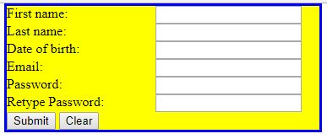

[First name] [Last name], your age is.. and your email address is ….

The form is centered in the middle of the window with Border 3px solid blue, Width approx. = 650.

1. **Hints:**
2. Compute the age using a function
3. Use the book and do not forget to create folders for the css and js files
4. Remember to create another function that helps you get the id of the tags if you need.